**1.Write a c program to find the AVL tree**

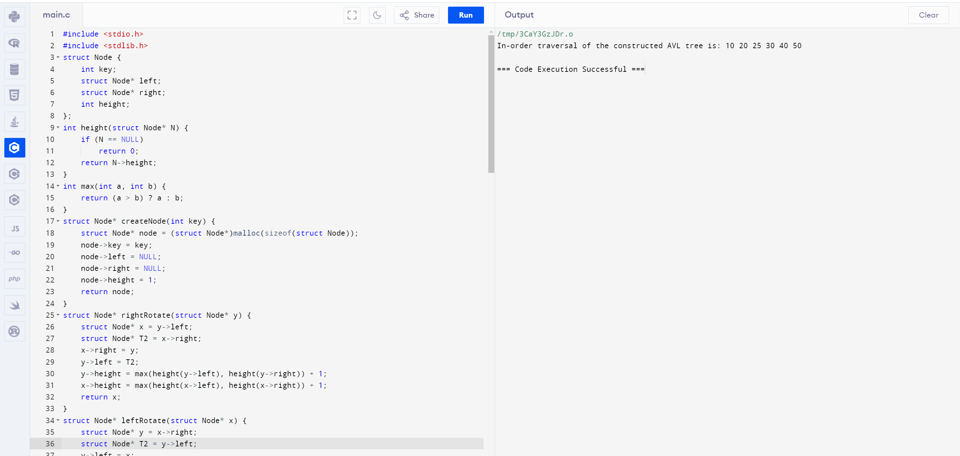

**2.Write a problem on deletion operation (AVL Tree)**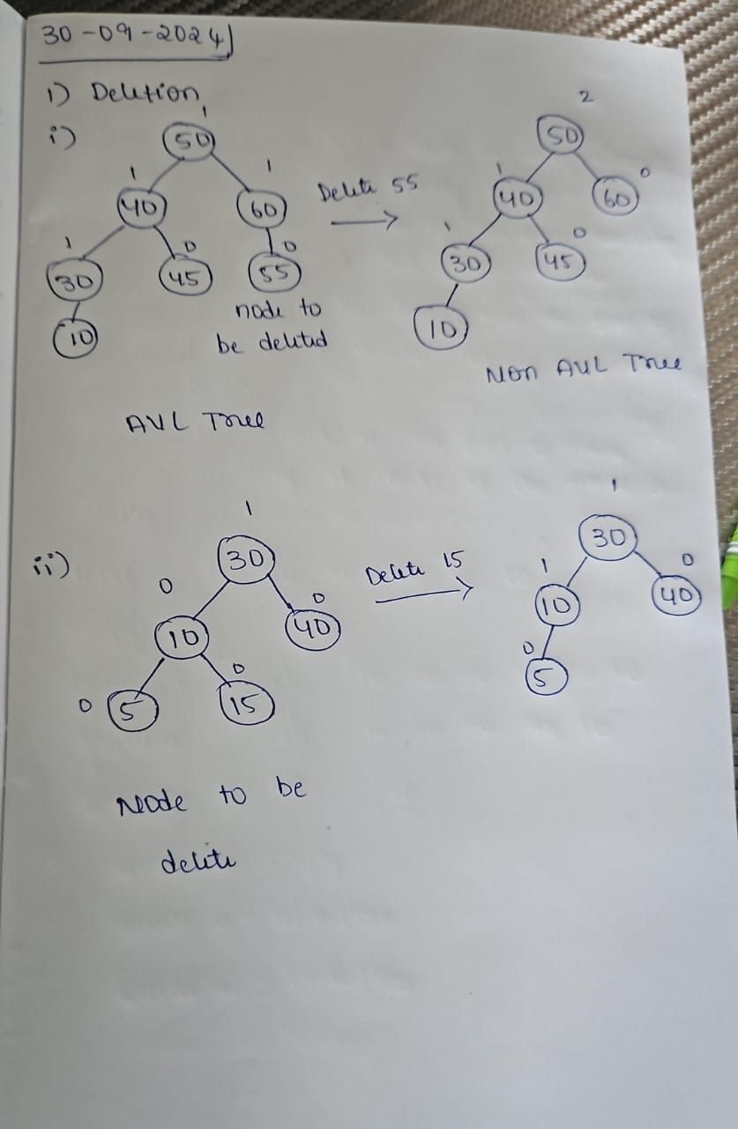

**3.Write a problem on searching operation (AVL Tree)**

